3-D Printing
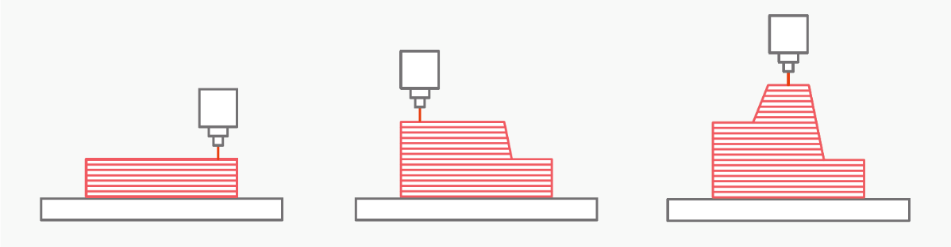
All the colorful plastic pieces on the claw were custom made on a 3-D printer! The 3-D printer works by melting a thin string of plastic and layering it on top of itself over and over again. After the plastic has been laid down it begins to cool and harden, slowly building your design from the bottom up.
This type of 3-D printing is called fused filament fabrication (FFF). While it is the most common, FFF it is not the only way people can 3-D print digital files.
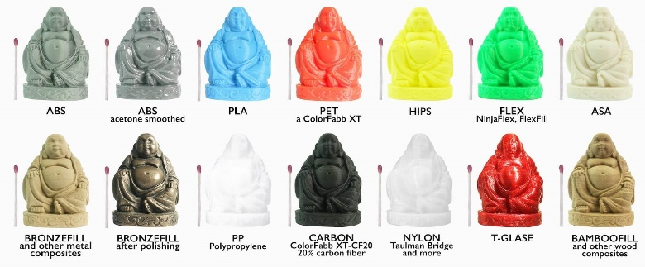
This process is called additive manufacturing because it adds material layer by layer until the final product is finished. If you look closely you can see the individual layers in each of the pieces! This is the opposite of subtractive manufacturing techniques such as wood carving where you take a large block of material and sculpt away the material you don’t want.
There are lots of different plastics available to 3-D print, allowing hard or soft objects, even plastic that looks like wood or metal!
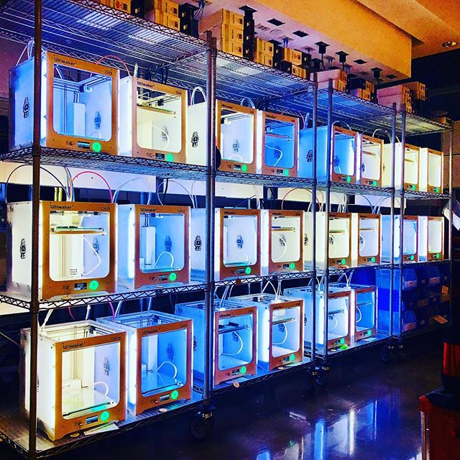
In order to 3-D print an object you first must design it digitally using a 3-D modeling program. Alternatively, you can scan a 3-D item on a special scanner or download a pre-made design from the internet. Once your design is ready, it’s time to use it on a 3-D printer. Although prices for 3-D printers are decreasing (as low as $200), not many people own their own printer. Often times a google search can show you the nearest library, school or makerspace with shared printers.
Left: collection of 3-D printers for students of UNC Chapel Hill to use at the BEAM makerspace.
Right: computer design of printer claw used in the mechanical arm
Want to learn more about 3-D printing?
- Kids guide to 3-D printing:
https://3dinsider.com/3d-printing-for-kids/
- Learn how to design objects for 3-D printing: https://www.shapeways.com/tutorials/introduction-to-3d-design-printing-for-kids
- Find all types of cool project ideas and designs:
https://www.thingiverse.com/
- New light-based printing technique developed at UNC Chapel-Hill:
https://www.youtube.com/watch?v=kR7iDnrAxAU
Laser Cutting
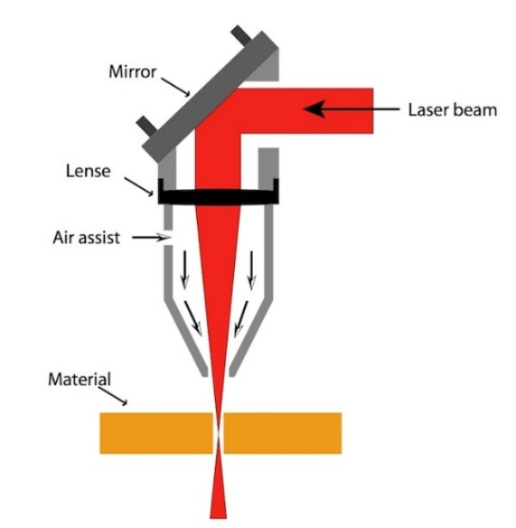
Lasers are no longer just science fiction. Notice how the wood edges of the claw look and smell burnt? That’s the result of a high-powered laser beam precisely cutting shapes in a thin plywood sheet.
Left: the incoming laser beam is focused into a narrow, high energy beam of light
Right: a laser cutting out hexagons from a flat sheet of plywood

Lasers are more than just powerful flashlights. The difference between ordinary light and laser light all comes from how the light is organized. Imagine randomly splashing water around in a bathtub. As the waves move around they crash into each other, lose energy, and never get very big. However, if you move your hand back and forth at just the right speed you can make quite strong waves that get bigger every time they pass by. Lasers work similarly by pumping more energy into the light in a very organized fashion continually making it stronger.
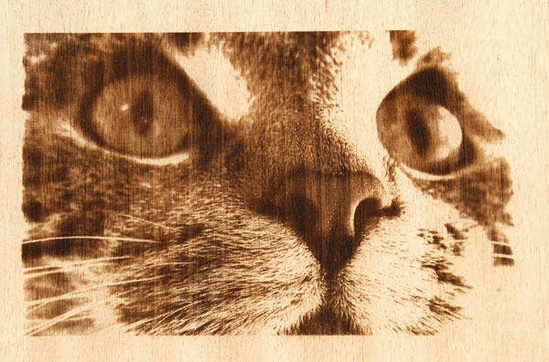
Laser technology has allowed us to create lasers that pump out trillions of photons (light particles) at once, with enough energy to burn through paper, wood, or even metal!
This cat was made using a laser cutter on plywood. The power output of the laser cutter can be finely tuned, allowing you to choose how deep/dark the laser burns giving the option to add shading to your pieces!

Want to learn more about lasers?
- Here’s a more detailed explanation of how lasers work
https://www.explainthatstuff.com/lasers.html

Hydraulics
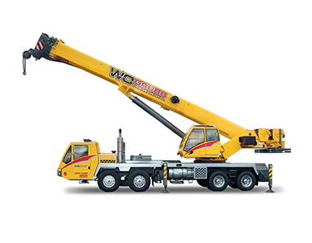
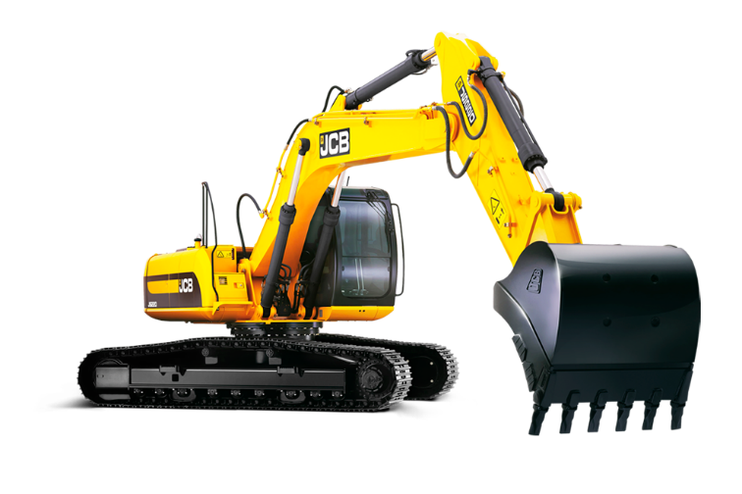
The syringes in the mechanical claw use liquids under pressure in order to move objects. This is a simple example of hand-built hydraulic machine! By pushing on a syringe, force is transferred through tubing to a second syringe where it can move an object, also known as doing work. Hydraulics are also used in the real world. For example, have you ever noticed the cylindrical steel rods on heavy machinery such as excavators or cranes? Those are simply very strong syringes, or pistons, that are used to do large amounts of work on heavy objects.
These machines use powerful diesel engines to generate enough force to lift heavy objects high above the skyline or dig holes in hard packed earth. The force in these pistons are often in excess of 3,500 pounds per square inch (PSI) of pressure!

Hydraulics are also used to keep you safe while driving your car. Did you know car brakes by using a hydraulic syringe to push a brake pad against a brake disc. When the pad and disc rub against each other it converts the kinetic energy of your car into heat through friction, slowing you to a safe stop.
Want to learn more about hydraulics?
- Here’s a more detailed explanation on hydraulics:
https://www.explainthatstuff.com/hydraulics.html

